𝗟𝗲𝗮𝗿𝗻 𝗣𝗮𝗿𝗾𝘂𝗲𝘁 𝗙𝗶𝗹𝗲𝘀 𝗶𝗻 𝟵𝟬 𝗦𝗲𝗰𝗼𝗻𝗱𝘀 📦
Almost every modern Data Engineer works with Parquet.
But very few understand why it's so fast.
If I asked you:
❓ Why is Parquet called a columnar file format?
❓ What are Row Groups, Column Chunks, and Pages?
❓ Why do analytical queries run much faster on Parquet than CSV?
❓ What does the Footer actually store?
❓ How do compression and encoding reduce storage without sacrificing performance?
Could you explain it?
If not, this notebook is for you. 📒
In just 90 seconds, you'll understand how Parquet stores data and why it has become the de facto file format for modern data lakes and lakehouses.
📖 Here's what you'll learn:
✅ What Parquet really is
✅ How a Parquet file is structured
✅ The role of Row Groups, Column Chunks, and Pages
✅ Why the Footer is the brain of every Parquet file
✅ How columnar storage speeds up analytical queries
✅ Why compression works better in Parquet than row-based formats
✅ Common compression codecs like Snappy, ZSTD, Gzip, and Brotli
✅ How encoding techniques reduce file size even further
✅ Why Parquet works so well with Spark, Snowflake, Databricks, Trino, and other analytics engines
✅ Best practices for designing efficient Parquet files
💡 The one concept every Data Engineer should remember:
𝗣𝗮𝗿𝗾𝘂𝗲𝘁 ≠ 𝗝𝘂𝘀𝘁 𝗔𝗻𝗼𝘁𝗵𝗲𝗿 𝗙𝗶𝗹𝗲 𝗙𝗼𝗿𝗺𝗮𝘁
It's designed specifically for analytics.
📄 Columnar Storage → Read only the columns you need
🗂️ Row Groups → Organize data into independent blocks
📦 Column Chunks & Pages → Store and compress data efficiently
📝 Footer Metadata → Keeps schema and file structure information
🗜️ Compression & Encoding → Reduce storage while improving scan performance
Together, these capabilities make Parquet one of the biggest reasons modern analytics platforms can process terabytes or even petabytes of data efficiently.
I created this notebook because I believe understanding how technologies work internally is much more valuable than simply knowing how to read or write files.
Once you understand Parquet's architecture, concepts like Predicate Pushdown, Column Pruning, Partitioning, Delta Lake, Apache Iceberg, ORC, and Spark performance optimization become much easier to understand.
💾 Save this post—you'll thank yourself before your next Spark, Databricks, Snowflake, or Data Engineering interview, or the next time you're optimizing a slow query on a massive dataset.
📌𝗘𝗻𝗿𝗼𝗹𝗹 𝗻𝗼𝘄 𝗶𝗻 𝗼𝘂𝗿 𝟰𝘁𝗵 𝗗𝗮𝘁𝗮 𝗘𝗻𝗴𝗶𝗻𝗲𝗲𝗿𝗶𝗻𝗴 𝗖𝗼𝗵𝗼𝗿𝘁 𝗮𝗻𝗱 𝗸𝗶𝗰𝗸𝘀𝘁𝗮𝗿𝘁 𝘆𝗼𝘂𝗿 𝗗𝗮𝘁𝗮 𝗘𝗻𝗴𝗶𝗻𝗲𝗲𝗿𝗶𝗻𝗴 𝗷𝗼𝘂𝗿𝗻𝗲𝘆 - https://lnkd.in/gPiDZuyS
Activate to view larger image,
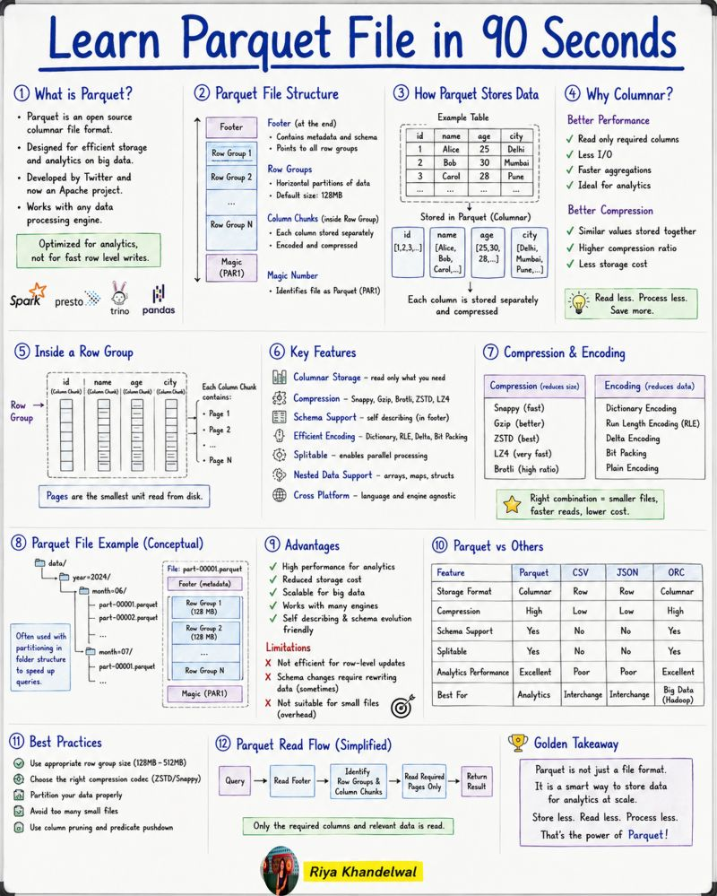

𝗟𝗲𝗮𝗿𝗻 𝗣𝗮𝗿𝗾𝘂𝗲𝘁 𝗙𝗶𝗹𝗲𝘀 𝗶𝗻 𝟵𝟬 𝗦𝗲𝗰𝗼𝗻𝗱𝘀 📦
Almost every modern Data Engineer works with Parquet.
But very few actually understand why it's so fast.
Here's the quick version👇
Parquet is a columnar file format — meaning instead of storing data row by row like CSV, it stores each column separately. This single design decision is what makes it incredibly powerful for analytics.
When you run a query, you only read the columns you actually need. Less I/O. Faster results. Lower cost.
And because similar values are stored together, compression becomes dramatically more effective — codecs like Snappy, ZSTD, and Gzip can squeeze your data without hurting read performance.
Under the hood, a Parquet file is organized into Row Groups → Column Chunks → Pages, with a Footer that acts as the brain — storing all the metadata, schema, and file structure information so engines like Spark, Snowflake, and Databricks know exactly where to look.
💡 The one concept every Data Engineer should remember:
𝗣𝗮𝗿𝗾𝘂𝗲𝘁 ≠ 𝗝𝘂𝘀𝘁 𝗔𝗻𝗼𝘁𝗵𝗲𝗿 𝗙𝗶𝗹𝗲 𝗙𝗼𝗿𝗺𝗮𝘁
It was built specifically for analytics at scale.
Once you understand its architecture, concepts like Predicate Pushdown, Column Pruning, Delta Lake, Apache Iceberg, and Spark optimization all start to make much more sense.
The foundation always matters.
💾 Save this post— you'll thank yourself before your next Data Engineering interview or the next time you're optimizing a slow query on a massive dataset.
♻️ Repost to help someone on your team level up their data engineering fundamentals.
hashtag#DataEngineering hashtag#Parquet hashtag#BigData hashtag#ApacheSpark hashtag#Databricks hashtag#Snowflake hashtag#DataLake hashtag#Analytics hashtag#Python hashtag#TechLearning
Activate to view larger image,
